Neural networks and back-propagation explained in a simple way
[1]: https://medium.com/datathings/neural-networks-and-backpropagation-explained-in-a-simple-way-f540a3611f5e
The learning process:
In → Inputs and desired outputs
Aim → Updates its internal state accordingly. → The calculated output is as close as possible to the desired output.
- The output is is generated according to a training experience. → Machine Learning is called Model Fitting.
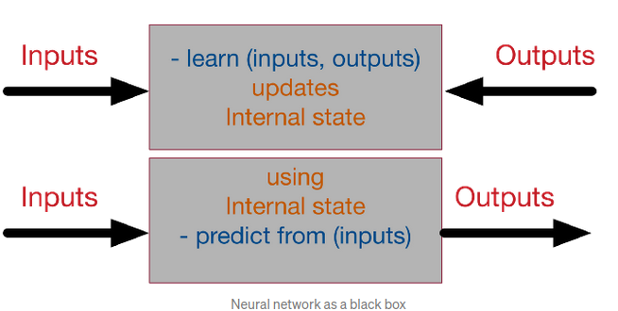

Steps:

1/ Model Initialization: Initial Hypothesis: a random initialization.
Next, through the learning process, the models will converge to the ideal solution.
(Example: In linear layers, the model is initialized as follows: y=W.x, where W is the weight of the network and be randomly initialized).

2/ Forward propagate: Check the performance of the model at random.
Input → Neural Network → Output.

3/ Loss Function:
Def: an error metric, which is an indicator on the precision of a NN to reach the desired output from an actual output (also called the error cost function).
Loss = Absolute value of (desired — actual )
Loss function = sum of squares of the absolute errors

4/ Differentiation
Problematic:
optimization technique to minimize the total loss function, including: genetic algorithms, greedy search, a simple brute-force search.

 | Definition
Brute-Force Search/ Exhaustive Search/ Generate and Test | Enumerate all possible candidates for the solution and check whether each candidate satisfies the problem's statement. [2]
Greedy Search | Problem-solving of making the locally optimal choice at each stage. [3]

[2]: https://en.wikipedia.org/wiki/Brute-force_search
[3]: https://en.wikipedia.org/wiki/Greedy_algorithm

→ brute force: Waste of computational resources and is only used when the model has very few parameters and accuracy is not needed. → Not used in image processing.

Solution: Differentiation Technique (Derivative of the loss function):
* We vary the internal NN weight with a certain small value δW → * how will the total error vary?
→ W+ δW or W - δW depending on the derivative of the loss function (<0 or >0).

5/ Back Propagation
Hidden layers between the input and outputs for more variations in the functionality of the neural network.
*Forward-propagate (directly applying the function)
* back-propagate (calculating the derivative of the function)
In back-propagation, we sum the deltas coming from all the target layers.

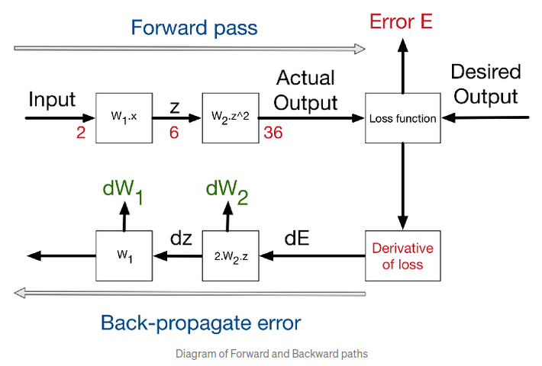

Input → Forward calls → Loss function → derivative→back-propagation of errors.

6/ Weight Update
The delta rule:
New weight = old weight — Derivative * learning rate ; with the learning rate having very small.
*Best Practice:
- Update the weights every Batch Size=N of training → mini-batch gradient descend.
- N=1 → Full online-learning or stochastic gradient descent.

7/ Iterate until Convergence
- High learning rate means faster learning, also higher chance of instability.
- It depends on the random initialization of the network.
- It depends on the quality of the training set.

→ What we need to learn:

The execution of NN has 4 major steps: [4]
- Forward step (where we go from inputs to outputs)
- Loss function (where we compare the calculated outputs with real outputs)
- Backward step (where we calculate the first delta at the loss function and then back-propagate)
- Optimization step (where we update the internal weights with deltas and learning rate)
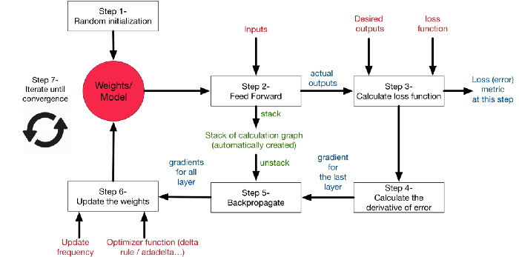
[4] https://medium.com/datathings/a-neural-network-fully-coded-in-numpy-and-tensorflow-cc275c2b14dd

Writing a simple neural network from scratch in C, without the help of any vector or matrix libraries:
powerful math libraries → numpy.

